Atlantic Beef Products Inc | Tenderloin (PSMO - 189)

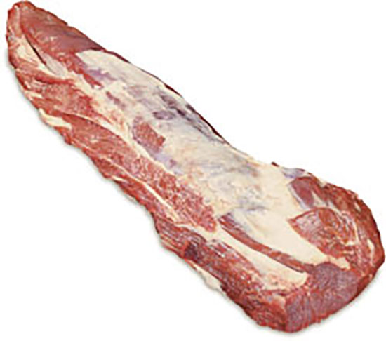  ABP’s Peeled Tenderloin is a fully defatted tenderloin removed from the loin primal by following the surface of the bones and natural seam, leaving the side muscle firmly attached. |  | Specification:  - Fat underneath ear is cut back to 1 inch  - Flaps on belly not to exceed 1/5 of an inch  - Side muscle remains firmly attached  Product Code:  Product codes available:  811 – Prime (2 pc/box)  828 – GTA (4/box)  598 – Blue Dot Reserve (4 pc/box)  611 – Certified Island Beef (4 pc/box)  798 – AAA (4 pc/box)  398 – AAA (5lbs and up/pc, 12 pc/box)  698 – AA (4 pc/box)  198 – A (4 pc/box)  150 – Ungraded (5lbs and up/pc, 10 pc/box)  086 – Ungraded (4lbs and under/pc, 10 pc/box)  Halal certified available upon request.  Shelf Life:  Fresh: 35 days  Frozen: 365 days  Packaging Details:  Vacuum packed 1 per bag  Bags/box stated under product code  Average case weight dependent on product code  Revision Date:  Date: January 2, 2019

